RCM Analytics Project

Data Collection

Data Was collected from Kaggle [RCM data](https://www.kaggle.com/datasets/abuthahir1998/synthetic-healthcare-claims-dataset).

About Dataset

This dataset contains randomly generated healthcare claims data intended for training machine learning models that predict the outcome of medical claims. Although the data mimics the structure and variety of typical medical claims, it is entirely synthetic and contains no actual patient information.

Data Analysis using SQL

1. Developed and optimized SQL queries to analyze healthcare claims data, including creating tables, checking data quality, and performing data aggregations for reporting purposes.
2. Created AR Aging Buckets and calculated Days in AR to track outstanding claims, facilitating better insights into claims aging and payment timelines.
3. Conducted in-depth analysis of claim denials, identifying primary denial reasons and calculating denial rates, which improved understanding of revenue cycle inefficiencies.
4. Generated financial insights by analyzing billed, allowed, and paid amounts across different insurance types and claim statuses, helping highlight trends and performance variations.
5. Tracked monthly billed vs. paid trends and developed summary statistics (e.g., average Days in AR by insurance type) to support financial planning and improve collections strategies.

For detailed Analysis please check the [GitHub](https://github.com/VipulJadhav26/PowerBI-Projects/blob/main/EDA%20queries.sql) Page.

Dashboard building using PowerBI

1. Built an interactive PowerBI dashboard to track key metrics such as Total Claims, Total AR, Denial Rate, and Average Days in AR, improving transparency in revenue cycle performance.
2. Designed dynamic AR Aging Buckets and Denial Rate calculations using DAX formulas, enabling detailed insights into claims aging and denial patterns.
3. Visualized denial trends and top denial reasons with line charts and pie charts, providing stakeholders with a clear view of denial rates over time and major denial reasons, enhancing decision-making capabilities.
4. Implemented advanced visualizations like a stacked column chart to display Total AR across aging buckets, allowing quick identification of high-value aged claims.
5. Enabled data filtering with slicers for date and insurance type, improving dashboard usability for detailed analysis and empowering end-users to tailor insights based on specific parameters.

The dashboard looks something like this  
  
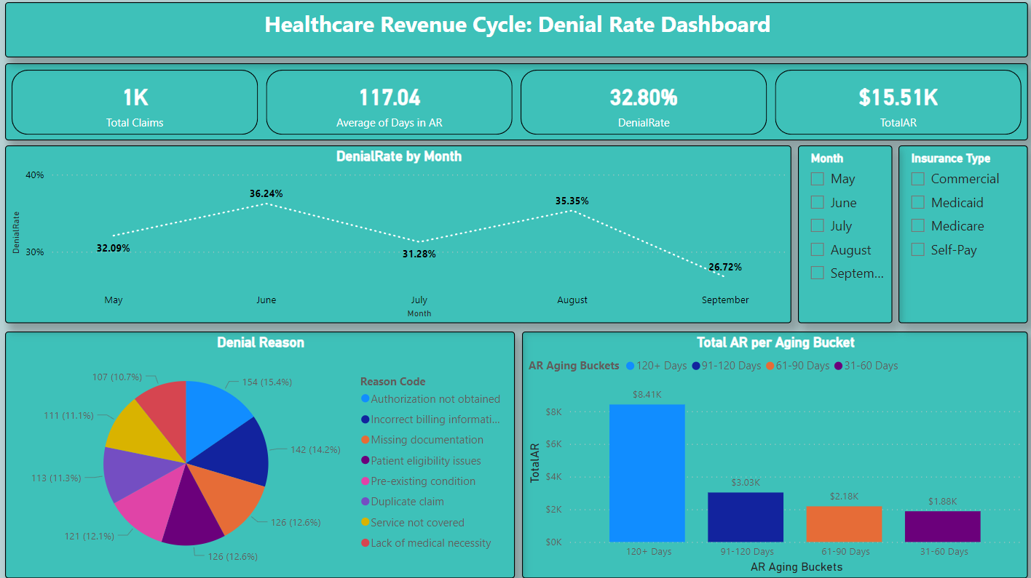

Click on [PowerBI](https://github.com/VipulJadhav26/PowerBI-Projects/blob/main/RCM%20Analytics.pbix) to download and view the dashboard.